# User Manual

This QA system has an extremely simple user interface. When you enter the frontend of the QA system, you will find a chat window, an input box and an enter button in the user interface. 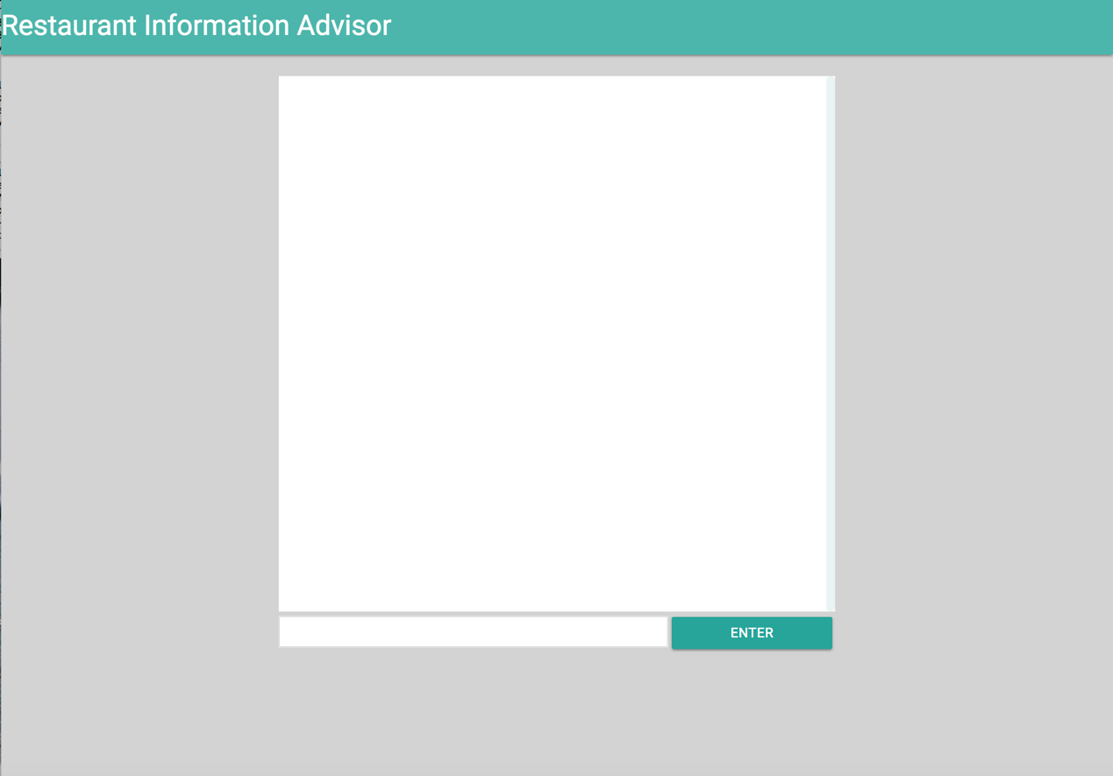To ask your question, you just need to enter your question in the input box and then click the ENTER button. Then the question will be posted to the QA system and then you can find you question in the chat window

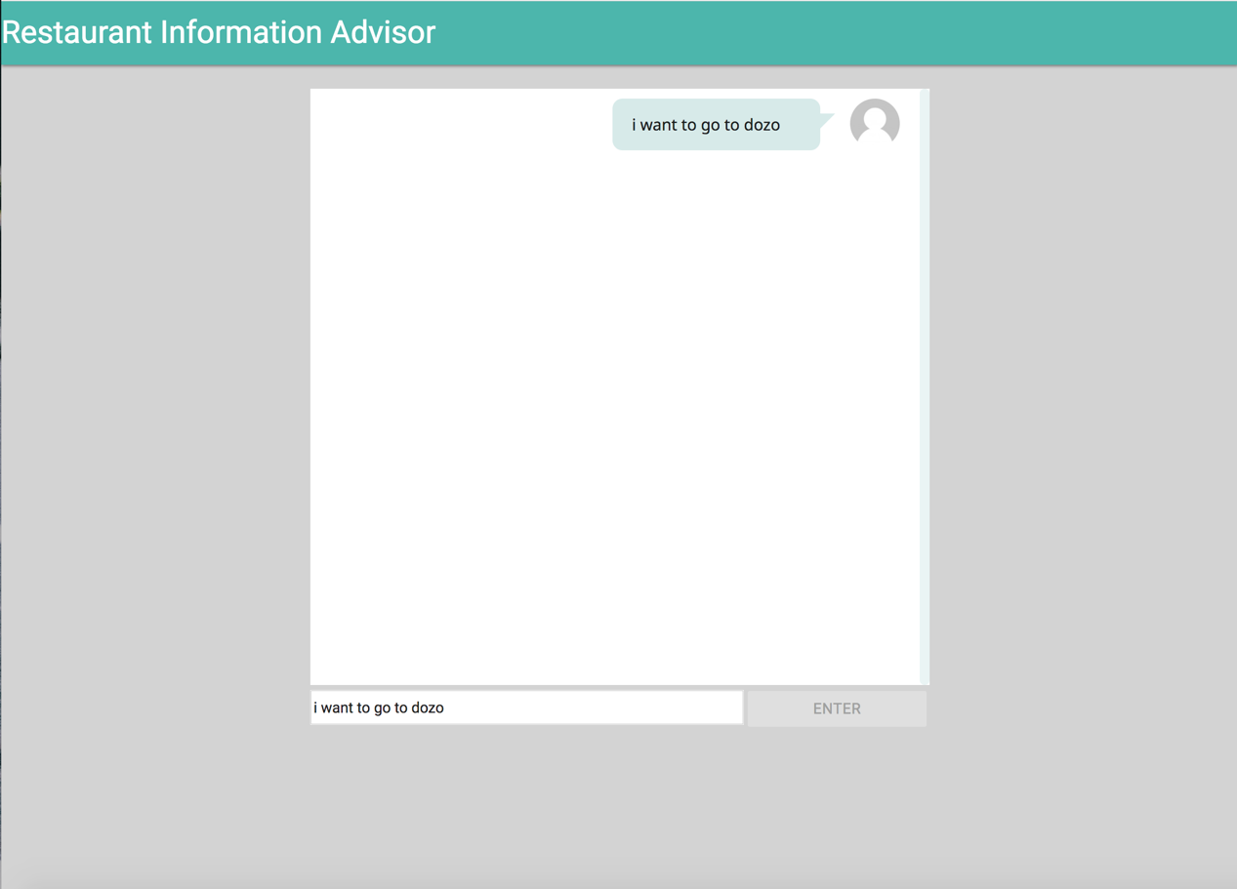

Then the answer will be shown on the chat window in seconds.

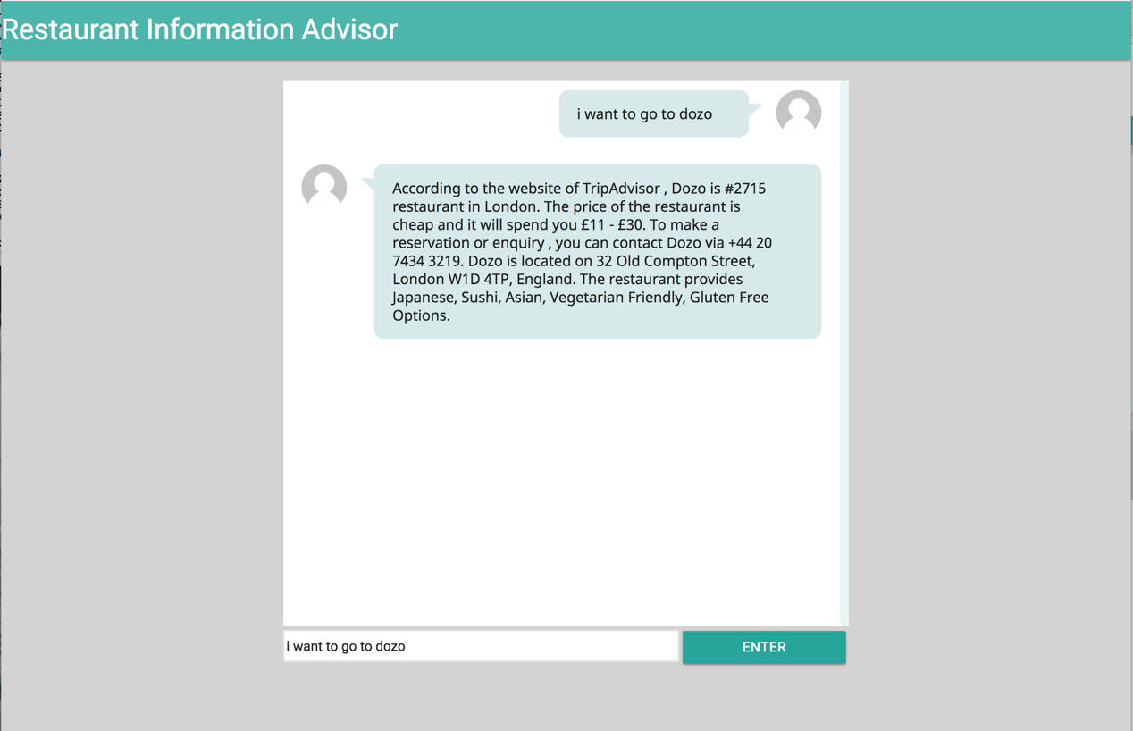

If the answer contains several options, you can reply with number to get further information.